Hurricane Hat (Top Down adaption)
Create July 4, 2016, by sldeskins
(based on http://www.ravelry.com/patterns/library/hurricane-hat)

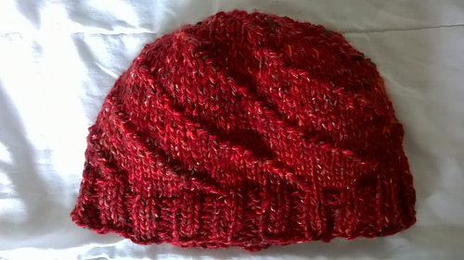

Adult Medium: 18” circumference, 7.5” length

Gauge: 7 stitches per 2”, 11 rows per 2”
(Size 9 needles - 5.5mm)

Yarn: Aran weight, 92 yards
(1 skein Berroco Uxbridge Tweed)

Crown: increase (decrease) 1-14 rounds
Body: multiple of 9 stitches x 9 repeats (81 stitches) ~3”
Edge: 2x2 (k2, p2) ribbing (80 stitches) ~1.25”

Crown
Begin: loop cast on 9 stitches – spread among three needles, place marker on beginning of round.
2: Mpk, in each stitch (18 stitches)
3: *p1, Mkk* repeat around (27 stitches)
4: *k, p, Mkk* repeat around (36 stitches) [increase round]
5: *k2, p, k* repeat around (36 stitches)
6: *k3, Mpk* repeat around (45 stitches) [increase round]
7: *p, 4k* repeat around (45 stitches)
8: *k, p, k2, Mkk* repeat around (54 stitches) [increase round]
9: *k2, p, k3* repeat around (54 stitches)
10: *k3, p, k, Mkk* repeat around (63 stitches) [increase round]
11: *k4, p, k2* repeat around (63 stitches)
12: *k5, p, Mkk* repeat around (72 stitches) [increase round]
13: *k6, p, k* repeat around (72 stitches)
14: *k7, Mpk* repeat around (81 stitches) [increase round]

Body
(pattern 9 rows, over 81 stitches))
15: *k8, p*
16: *p, k8*
17: *k1, p, k7*
18: *k2, p, k6*
19: *k3, p, k5*
20: *k4, p, k4*
21: *k5, p, k3*
22: *k6, p, k2*
23: *k7, p, k1*
(repeat for about 3” for medium)

Edge
First round Ktog, 1k at start of pattern. (i.e. decrease one stitch to get 80 stitches)

2x2 (k2, p2) ribbing (80 stitches)

(repeat for about 1.25” for medium)

Finishing: Use a loose cast off. Sew in ends.

Special notations:
Mpk – Make 1, in same stitch, purl, twist other half of stitch, knit.
Mkk – Make 1, in same stitch, knit, twist other half of stitch, knit.

